

“Caring for the Land and Serving People”

OUTREACH NOTICE

GS-0401-11/12 Bend Seed Extractory Manager
Detail 120 NTE and Permanent full-time position

USFS Bend Seed Extractory
Bend, Oregon

PLEASE NOTE: The purpose of this outreach notice is to determine the potential applicant pool for this a potential detail and permanent position as well as establish the appropriate recruitment method and area of consideration for the advertisement.

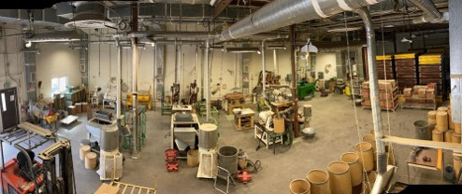

Reply due date is no later than September 12, 2022

*Candidates who respond to this Outreach will receive an email with the vacancy open and close dates and announcement number as soon as it becomes available.

ABOUT THE POSITION:

The incumbent must be able to:
- Manage a Working Capital Fund budget, which includes billing for all services provided.
- Lead and direct others in performing seed processing work.
- Effectively meet and communicate production needs and schedules.
- Operate and maintain or facilitate maintenance of equipment and tools needed to perform the duties of the position, (i.e. seed machines, sieves, compressors, seed freezer, etc.).
- This position also serves as a Contracting Officer Representative on contracts for seed testing and facility needs.
- This position requires the incumbent to participate in the BSE respiratory protection plan.
- Coordinate with regional and forest facilities programs in regards to extractory needs.

The major duties of this position are in support of the R6 Seed Extractory’s current program.
Duties may include but are not limited to:
- Responsible for incoming and outgoing shipments: seed delivery and check-in, load/unload seed and cone shipments, seed orders, seed storage.
- Coordinates with clients from various agencies regarding processing capacity, pricing and billing, processing data, and seed shipments. Understanding of both native species and conifers.
- Responsible for data entry, data management, and reporting in NMIS (Nursery Management Information System - Oracle database).
- Processes native plant and conifer seed from across the United States for research & outplanting purposes in a warehouse/laboratory setting. The extractory works with more than 3,800 different species.
- Operates numerous seed processing machines, which requires extensive cleanup & vacuuming between seedlots. This also includes operation of a forklift and scissor lift.
- Uses various types of seed testing/laboratory balances and meters, digital x-ray equipment, stereoscopes.
- This position will be exposed to dusty, noisy conditions and can be standing for long periods of time while processing various seedlots. Required to lift up to 50 pounds.

This position integrates with the National Nursery Team, Regional Silviculture Group, Regional Botany Group, Region 6 Geneticists, and Forest Program Managers to address seed needs across Region 6. This position also works with state and regional leads to manage seed needs for city, state, and federal entities. This position is part of the Deschutes National Forest Natural Resources Staff Organization and reports to the Natural Resources Staff Officer.

EMPLOYEE WELLBEING AND WORKPLACE ENVIRONMENT

The Deschutes and Ochoco National Forests and Crooked River National Grassland have several shared program manager positions as well as a shared Forest Leadership Team (FLT). In central Oregon, the Forest Service focuses on collaboration, partnerships, and shared stewardship to accomplish holistic landscape scale restoration and provide for healthy forests, watersheds, economies, and communities.

In this work, employee wellbeing is a core value and one that is strongly supported by the FLT and employees themselves. We have several complimentary efforts working together to enhance the workplace environment and support individual wellness such as the Central Oregon Comprehensive Wellness Advocates, Workplace Culture Working Group, and Women in COFMS (Central Oregon Fire Management Services). In addition, the Central Oregon Civil Rights Committee is very active in promoting and honoring cultural awareness, allyship, and diversity, equity, and inclusion. We take pride in our grassroots approaches to supporting employees locally by listening to their needs, providing peer support, and amplifying regional and national resources.

ABOUT BEND

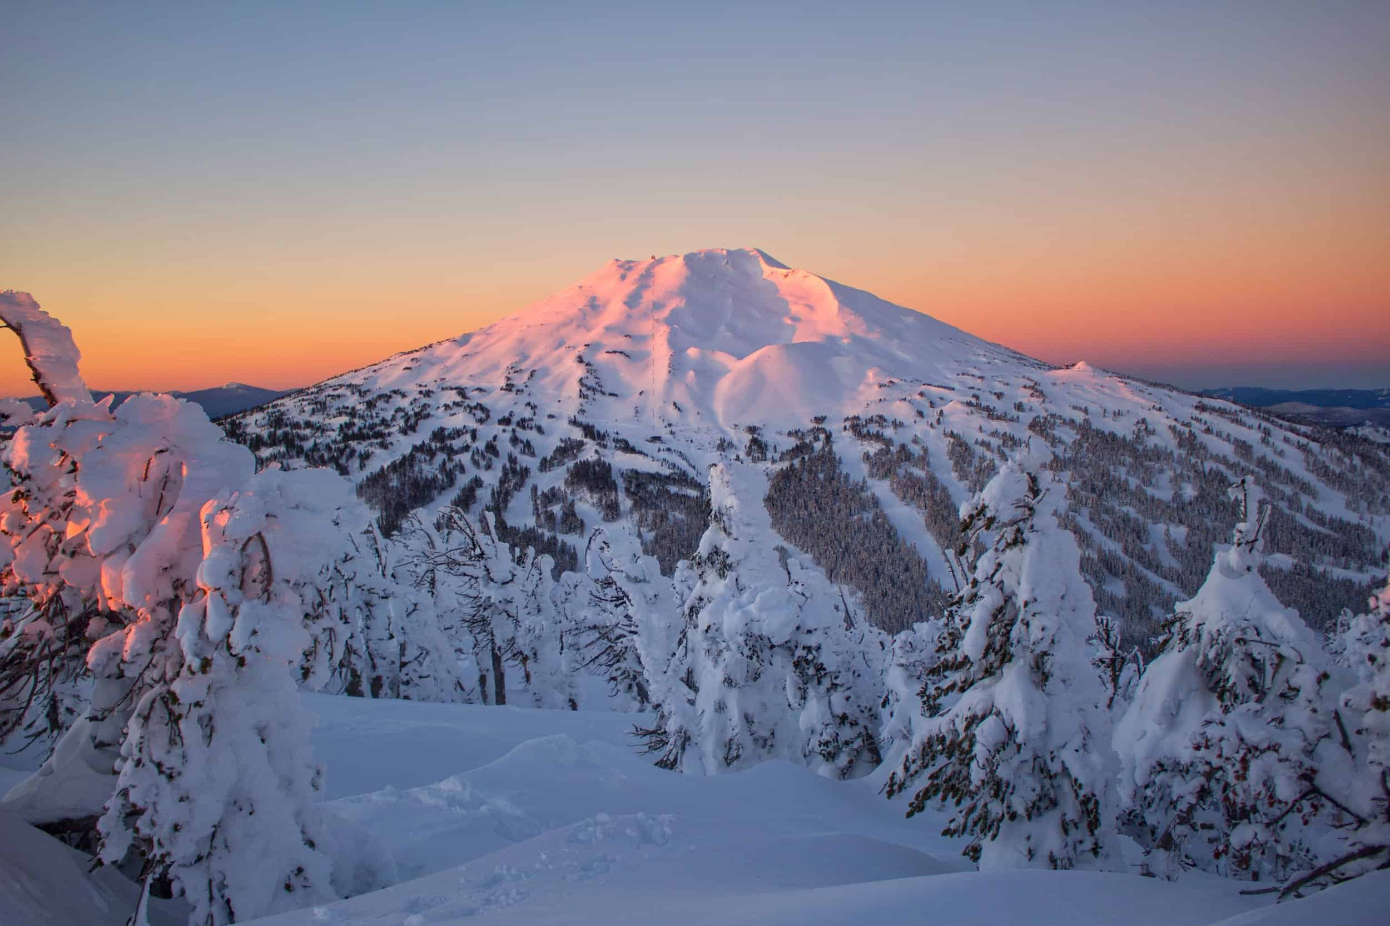
The City of Bend resides at the base of the beautiful Cascade mountains in central Oregon and has become one of the fastest growing communities in the nation. The area has long been a mecca for outdoor enthusiasts, with easy access to mountain biking, Nordic ski trails, hiking trails, river and lake recreation, and Mt. Bachelor ski resort. Bend and the surrounding area also boast over 30 breweries, dozens of restaurants, and year-round entertainment such as downtown festivals, summer concert series, the Bend Film Fest, and numerous athletic events.

More detailed information about the Bend/Central Oregon area may be obtained from the Bend Chamber of Commerce web site at www.bendchamber.org.

Information about the nearby community of Prineville and Crook County can be found at: http://co.crook.or.us/AbouttheCounty/tabid/56/Default.aspx and at http://www.cityofprineville.com/

COMMUNITY INFORMATION

Elevation: 3,623 feet
Population: over 93,000
County: Deschutes
Location: East side of the Cascade Mountains in Central Oregon. 20 miles southeast of Sisters and 15 miles south of Redmond, Oregon
Average Summer Temperatures: 85º/day 44º/night
Average Winter Temperatures: 41º/day 21º/night
Average Annual Precipitation: 12” (mostly in the form of winter snow)
Closest Commercial Airport: Redmond, Oregon (an easy 15-mile drive to the north).
serviced by United, Delta, Allegiant, and Alaska Airlines
SCHOOLS

Bend is known for high quality public education and is served by public and private schools from pre-school through high school. Bend also offers college level community education courses locally through Central Oregon Community College (COCC) and Oregon State University (OSU) Cascades.

HEALTH CARE

Bend has one major hospital (St. Charles) and numerous clinics. Redmond offers one community hospital, located about 20 miles north of Bend.

HOUSING

A residential single-family home median sale price is around $642,000 and average rentals are approximately $1,600 per month. Prices in Redmond and La Pine are typically lower.
There is no long-term government housing available in Bend.

Please indicate your interest in this position by completing and returning the attached Outreach Interest Form to both Kristen McBride kristen.mcbride@usda.gov and Kayla Herriman kayla.herriman@usda.gov

For additional information or questions, please contact:
Kayla Herriman, Bend Seed Extractory Manager
Deschutes National Forest, 63095 Deschutes Market Road, Bend, Oregon 97701
Email: kayla.herriman@usda.gov
Phone: (541) 383-5481
Reply due date is no later than September 12, 2022.


USDA Non-Discrimination Statement
Revised 6/8/2005
“The U.S. Department of Agriculture (USDA) prohibits discrimination in all its programs and activities on the basis of race, color, national origin, age, disability, and where applicable, sex, marital status, familial status, parental status, religion, sexual orientation, genetic information, political beliefs, reprisal, or because all or part of an individual’s income is derived from any public assistance program. (Not all prohibited bases apply to all programs.) Persons with disabilities who require alternative means for communication of program information (Braille, large print, audiotape, etc.) should contact USDA’s TARGET Center at (202)720-2600 (voice and TDD). To file a complaint of discrimination, write to USDA, Director, Office of Civil Rights, 1400 Independence Avenue, S.W., Washington, DC 20250-9410, or call (800) 795-3272 (voice) or (202) 720-6382 (TDD). USDA is an equal opportunity provider and employer.”
OUTREACH INTEREST FORM

Deschutes and Ochoco National Forests and Crooked River National Grassland

Bend Seed Extractory Manager GS-0401-11/12
Detail Opportunity and Permanent Full-time Position

NAME:

EMAIL ADDRESS:

MAILING ADDRESS:

TELEPHONE NUMBER:

GOVERNMENT AGENCY EMPLOYED WITH: USFS____ BLM____ OTHER:

TYPE OF CURRENT APPOINTMENT: PERMANENT TEMPORARY TERM OTHER

CURRENT AGENCY/REGION/FOREST/DISTRICT:

CURRENT SERIES AND GRADE:

CURRENT POSITION TITLE:

Completed forms should be sent electronically or hard copy by September 12, 2022 to both:

Kristen McBride, Natural Resources Staff Officer
Deschutes National Forest, 63095 Deschutes Market Road, Bend, Oregon 97701
Email: kristen.mcbride@usda.gov

AND

Kayla Herriman, Bend Seed Extractory Manager
Deschutes National Forest, 63095 Deschutes Market Road, Bend, Oregon 97701
Email: kayla.herriman@usda.gov

